TOTUS Modbus Java Integration Application Note

Author: David Luca

Table of Contents

Document History 1

Introduction 2

Configure MODBUS on TOTUS 2

1. Configure Modbus via TCP 2

2. Configure Modbus via Serial 3

Totus Modbus Register map 3

Pre-requisites 4

Jamod setup 4

Project Setup 6

1 Connecting to Totus 7

1.1 Connecting via TCP 7

1.2 Connecting via Serial 8

2. Reading values from Totus unit 8

2.1 Reading temperatures 8

2.2 Reading alarms 9

2.3 Reading DGA values 9

Conclusions 10

# Document History

|  |  |  |  |
| --- | --- | --- | --- |
| Revision | Date | Author | Comments |
| 0.1 | 16/09/2014 | David Luca | First draft |
| 0.2 | 01/10/2014 | Paul McClean | Revised |

# Introduction

The purpose of the document is to introduce customers into using available MODBUS software libraries to connect their software to TOTUS instruments.

This document assumes you can access Totus interface by typing in your browser the IP address of the unit (in this document we will use <Totus-IP>). You may have to setup VPN connection, for which you need to contact Camlin Technologies.

# Configure MODBUS on TOTUS

## Configure Modbus via TCP

On TOTUS web interface navigate to **Settings**->**MODBUS** page. Press “Add New MODBUS Interface”, select “New TCP interface” then type in the form SlaveID (default 1) and the port to be used (i.e. 502, 1502) then press **Submit** button.

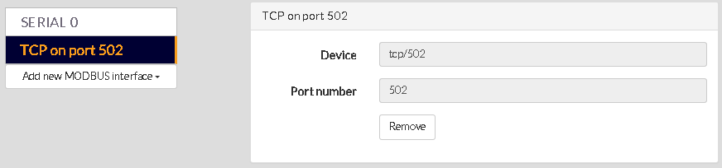

## Configure Modbus via Serial

On TOTUS web interface navigate to **Settings**->**MODBUS** page. Press “Add New MODBUS Interface” and select the Serial0, Serial1 or Serial2, specify on the form Baudrate, SlaveID (usually 1), data and stop bits, parity control, MODBUS protocol (ASCII/RTU) and flow control (usually “none” for RS232 or “hardware” for RS485 to enable direction via RTS line). For this application note we’ll be using 115200bps, 8 data bits, no parity, 1 stop bit then press **Submit** button.

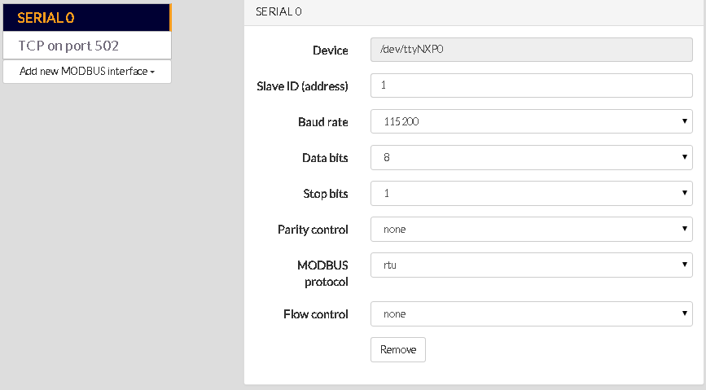

# Totus Modbus Register map

On TOTUS web interface navigate to **Settings**->**MODBUS** page. Click on the link “Download Register Map” for this device to download the MODBUS map for this device. This is a table of MODBUS protocol description, meaning of the fields and register transfer requirements to read and/or write into the dictionary.

e.g.:

0000_Common

|  |  |  |  |  |  |  |  |  |
| --- | --- | --- | --- | --- | --- | --- | --- | --- |
| **Topic** | **Address** | **Register** | **Number of Registers** | **Access** | **Format** | **Scaling** | **Offset** | **Notes** |
| UTC Time | 0 | 30001 | 2 | Read only | UINT32 |  |  | Clock time in UNIX time format; number of seconds from 1 Jan 1970. |
| ALARM/System/HL/State | 100 | 10101 | 1 | Read only | BOOLEAN |  |  | Combined system alarm for any non severe (H or L) alarm. |
| ALARM/System/HHLL/State | 101 | 10102 | 1 | Read only | BOOLEAN |  |  | Combined system alarm for any severe (HH or LL) alarm. |

# Pre-requisites

The code examples provided have been built using Netbeans IDE and Oracle Java 8 platform using latest version of JaMod sources from <http://sourceforge.net/projects/jamod/files/jamod/1.2/>.

You also need Java Communications API 3.0 from <http://www.oracle.com/technetwork/java/javasebusiness/downloads/java-archive-downloads-misc-419423.html#java_comm_api-30u1> if building for Solaris/Linux or for Windows you can use <http://smslib.org/download/> that provides links to different platforms for serial communication libraries.

The project Totus_jamod described below includes the Jamod 1.2rc1 built against RXTX library from Mfizz Inc. since Javax (Java Communications API) doesn’t support x64 bit Windows platforms, otherwise skip to “Project setup” section if using TCP or Javax.

From <http://mfizz.com/oss/rxtx-for-java> download <https://bitbucket.org/jlauer/mfz-cdn/downloads/mfz-rxtx-2.2-20081207-win-x64.zip> which contains RXTXcomm.jar that needs copied into jamod-1.2rc1-src\lib folder.

# Jamod setup

To build Jamod using NetBeans 8 extract the sources to an empty folder and select File -> New Project menu, then in **Categories** pick **Java** and then in **Projects** select **Java Free-Form Project** and hit **Next** button. After that you will configure the project by selecting the location of the project (jamod-1.2rc1-src/build.xml) and then associate targets in the build.xml with actions in the IDE and click Finish. Edit jamod-1.2rc1-src/build.properties file to enable build.serial.gnu=true for building against RXTX (Jamod website by default uses false so it’s built for Java Communications API comm.jar).

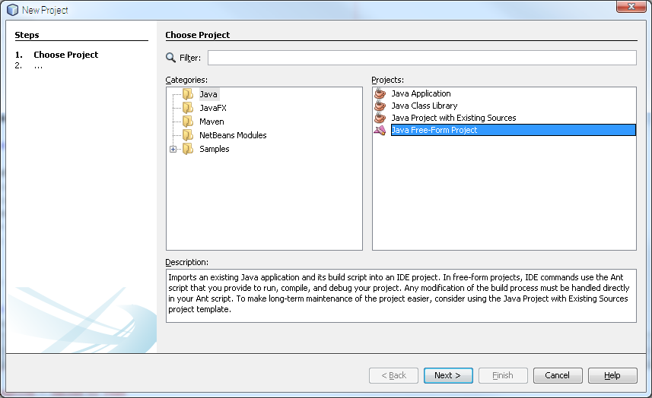

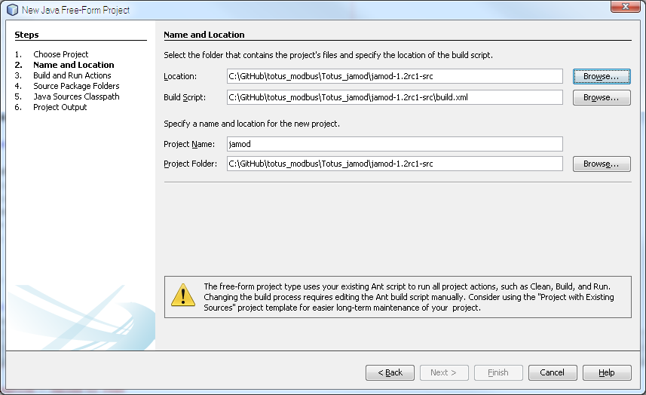

Click on build.xml and then right click on **“compile”** target, click on Run Target to compile classes, then click on **“jar”** and Run Target, which builds jamod.jar.

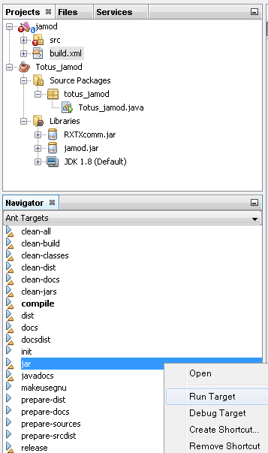

# Project Setup

Create a new project (e.g. totus_jamod) then add Jamod library to the project (either jamod-1.2rc1-src/build/jamod.jar built in previous step or the jamod-1.2-SNAPSHOT.jar from project website).

If using serial communication additionally include comm.jar (Java Communications API for Linux/Solaris) or jamod-1.2rc1-src/lib/RXTXcomm.jar (Windows) to project library by accessing Project Properties->Library category and **Add JAR/Folder** button:

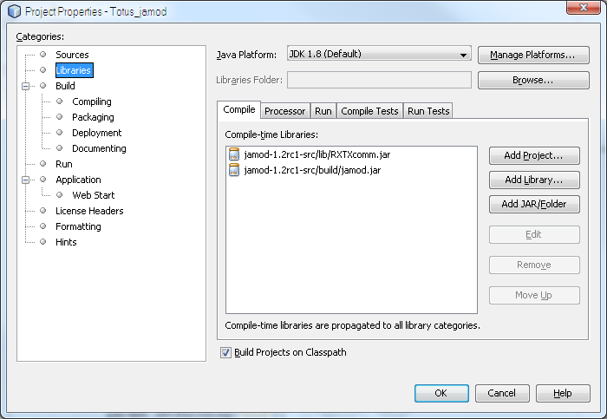

## 1 Connecting to Totus

Jump to section 1.1 if connecting via TCP or section 1.2 if connecting via Serial connection.

### 1.1 Connecting via TCP

The following example shows how to initiate a connection to Totus unit via TCP port specified in the settings form (502).

Imports required:

package totus_jamod;

import java.net.*;

import java.io.*;

import net.wimpi.modbus.*;

import net.wimpi.modbus.msg.*;

import net.wimpi.modbus.io.*;

import net.wimpi.modbus.net.*;

import net.wimpi.modbus.util.*;

import java.nio.*;

……

TCPMasterConnection con = new TCPMasterConnection(InetAddress.getByName("192.168.42.37"));

con.setPort(502); //port as configured on the unit

con.connect(); //connect to unit

ModbusTCPTransaction trans = new ModbusTCPTransaction(con);

### 1.2 Connecting via Serial

For Windows platforms you need to have the proper 32bit/64bit rxtxSerial.dll file in Totus_jamod application folder or in your Windows\System32 folder.

Imports required:

package totus_jamod;

import java.io.*;

import net.wimpi.modbus.*;

import net.wimpi.modbus.msg.*;

import net.wimpi.modbus.io.*;

import net.wimpi.modbus.net.*;

import net.wimpi.modbus.util.*;

import java.nio.*;

import gnu.io.*; //for RXTX library

//import javax.comm.*; //for Java Communications API;

……

SerialParameters params = new SerialParameters();

params.setPortName("COM1");//PC COM port

params.setBaudRate(115200);//baudrate set in Totus unit

params.setDatabits(SerialPort.DATABITS_8);

params.setParity(SerialPort.PARITY_NONE);

params.setStopbits(SerialPort.STOPBITS_1);

params.setEncoding("rtu"); //"ascii", "rtu"

params.setEcho(false);

//params.setReceiveTimeout(3000);//not available in RXTX

params.setFlowControlIn(SerialPort.FLOWCONTROL_NONE);//FLOWCONTROL_NONE for RS232, FLOWCONTROL_RTSCTS_IN for RS485

params.setFlowControlOut(SerialPort.FLOWCONTROL_NONE); ////FLOWCONTROL_NONE for RS232, FLOWCONTROL_RTSCTS_OUT for RS485

SerialConnection con = new SerialConnection(params);

ModbusSerialTransaction trans = new ModbusSerialTransaction(con);

## 2. Reading values from Totus unit

Reading is done via trans.setRequest() method that receive requests of type ReadInputRegistersRequest/ReadInputDiscretesRequest and calling trans.execute() then trans.getResponse() returns ReadInputRegistersResponse/ReadInputDiscretesResponse objects with array of values depending on the type of the dictionary.

### 2.1 Reading temperatures

int startAddress = 1000;

int numInputs = 10;

ReadInputRegistersRequest req = new ReadInputRegistersRequest(startAddress, numInputs);

req.setUnitID(1);

trans.setRequest(req);

trans.execute();

ReadInputRegistersResponse res = (ReadInputRegistersResponse)trans.getResponse();

String totusTemps[] = {

"Thermal/AmbientTemp",

"Thermal/AmbientTemp/1hAvg",

"Thermal/AmbientHumidity",

"Thermal/AmbientHumidity/1hAvg",

"Thermal/TopOilTemp",

"Thermal/TopOilTemp/1hAvg",

"Thermal/BottomOilTemp",

"Thermal/BottomOilTemp/1hAvg",

"Thermal/TapChangerTemp",

"Thermal/TapChangerTemp/1hAvg"

};

for (int i = 0; i < numInputs; i++)

{

float temp = res.getRegister(i).getValue();

System.out.println("Temp16 " + (startAddress + i) + " " + totusTemps[i] + " = " + temp / 10.0 + "°C");

}

### 2.2 Reading alarms

int startAddress = 100; //register map

int numInputs = 2;

ReadInputDiscretesRequest req = new ReadInputDiscretesRequest(startAddress, numInputs);

req.setUnitID(1); //slave ID of the unit

trans.setRequest(req);

trans.execute();

ReadInputDiscretesResponse res = (ReadInputDiscretesResponse)trans.getResponse();

String totusAlarms[] = {

"ALARM/System/HL/State",

"ALARM/System/HHLL/State"

};

for (int i = 0; i < numInputs; i++)

{

boolean bit = res.getDiscretes().getBit(i);

System.out.println("Alarm " + (startAddress + i) + " " + totusAlarms[i] + " = " + bit);

}

### 2.3 Reading DGA values

int startAddress = 2200;

int numInputs = 12;

ReadInputRegistersRequest req = new ReadInputRegistersRequest(startAddress, numInputs * 2);//float=2*ints16

req.setUnitID(1);

trans.setRequest(req);

trans.execute();

ReadInputRegistersResponse res = (ReadInputRegistersResponse)trans.getResponse();

String totusDGA[] = {

"DGA/SourceA/CH4",

"DGA/SourceA/C2H6",

"DGA/SourceA/C2H4",

"DGA/SourceA/C2H2",

"DGA/SourceA/CO",

"DGA/SourceA/CO2",

"DGA/SourceA/O2",

"DGA/SourceA/N2",

"DGA/SourceA/H2",

"DGA/SourceA/H2O",

"DGA/SourceA/TDCG",

"DGA/SourceA/THC"

};

for (int i = 0; i < numInputs; i++)

{

float ppm = Convert2Float(res.getRegister(i * 2).toBytes(), res.getRegister((i * 2) + 1).toBytes());

System.out.println("Float32 " + (startAddress + i * 2) + " " + totusDGA[i] + " = " + ppm + " ppm");

}

The floating point value are read as 16bit big endian values and assembled in a float using Convert2Float utility function:

public static float Convert2Float(byte[] a, byte[] b)

{

ByteBuffer bbuffer = ByteBuffer.allocate(a.length + b.length);

bbuffer.put(a);

bbuffer.put(b);

bbuffer.compact(); // no need if backing array is sized appropriately to begin with

float result = ByteBuffer.wrap(bbuffer.array()).order(ByteOrder.BIG_ENDIAN).getFloat();

return result;

}

# Conclusions

This document exemplified Modbus interfacing using Open-Source libraries for various programming platforms which allows customers to implement their own Human Machine Interface to extract information from Totus units.

Example output (values with 3276.7 are for not connected sensors):

